18.68:

b) Setting 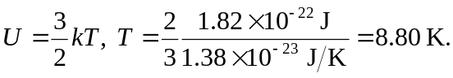 c) It is possible, but not at all likely for a molecule to rise to that altitude. This altitude is much larger than the mean free path.

